Output of Assignment 1

Create multiple accounts in Metamask and perform the balance transfer between the various accounts

Output of Assignment-2

Write a solidity program to set variable and get variable

Output of Assignment 3

Write a solidity program to perform push and pop operations on dynamic array

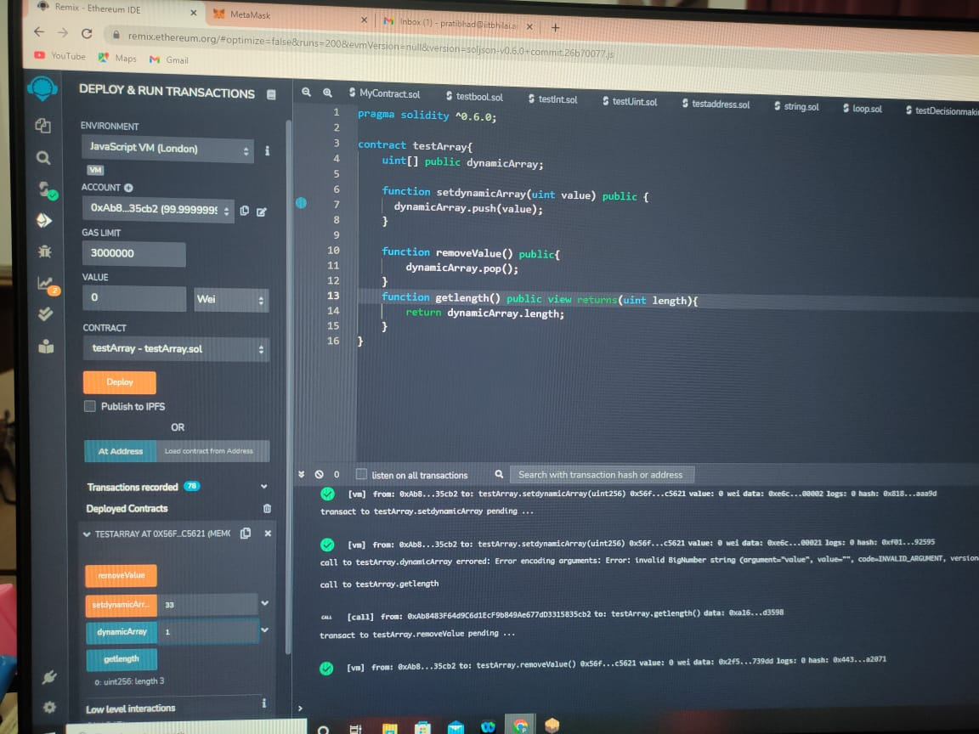

Output of Assignment 4

Write a solidity program to set address with a mapping variable

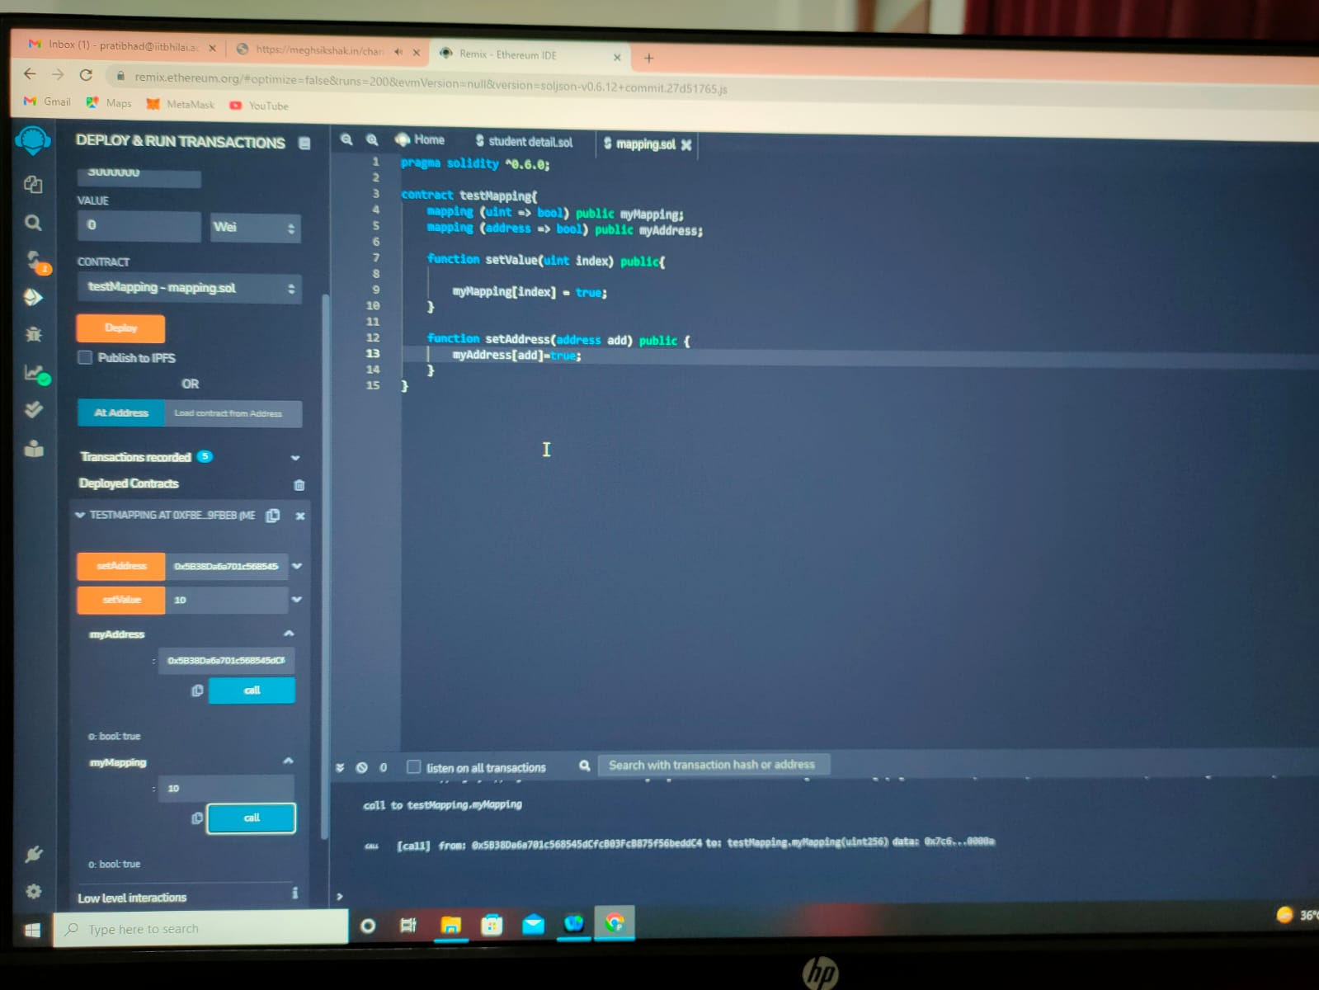

Output of Assignment 5

Write a solidity program to get the factorial of a number

Output of Assignment 6

Write a solidity program to store information of a student(Name, Roll.No, Institute, Age) using structure

Output of Assignment 7

Write a smart contract using a solidity program to perform balance transfer from contract to other accounts.

Output of Assignment 8

Write a smart contract using a solidity program to perform balance transfer with mapping and make sure only the owner can transfer the balance from contract to other contract.

Output of Assignment 9

Write a solidity program to perform the exception handling and describe the details with screenshots.

Output of Assignment 10

Connect the following tools with the remix IDE environment and perform balance transfer between the accounts with smart contract and share the screenshots.

a. Ganache

b. Metamask

